
 | The Interface Solution Experts | Moore Industries-International, Inc.
Editorial Contact: Rich Merritt (319) 892-0557  rmerritt@miinet.com |  | 16650 Schoenborn Street  North Hills, CA 91343-6196  Telephone (818) 894-7111  FAX (818) 891-2816  E-mail: info@miinet.com  www.miinet.com

Obtain Digital Photograph: ftp://editors.miinet.com Open “TRUNKSAFE Approved by Fieldbus Foundation” file, and download photo.

FOR IMMEDIATE RELEASE

TRUNKSAFE Fault-Tolerant Fieldbus Power Conditioner
Approved by Fieldbus Foundation
Achieving Fieldbus Foundation approval for the revolutionary TRUNKSAFE is a significant step, making it possible to protect critical processes economically.

NORTH HILLS, CA—The MooreHawke (a division of Moore Industries-International, Inc.) TRUNKSAFE TS Series power conditioner has been approved by the Fieldbus Foundation; it is now a Registered Product and listed on the Fieldbus Foundation web site (www.fieldbus.org).
“Because of the revolutionary nature of TRUNKSAFE, obtaining approval and registration is a significant step,” says Leonard Moore, president of Moore Industries. “TRUNKSAFE is the only fault-tolerant fieldbus system of its type in the world, and now end users and systems integrators can have complete confidence that it is suitable for use on both critical and non-critical process segments.”
Previously, to obtain a fault-tolerant, redundant FOUNDATION Fieldbus system, users had to duplicate everything in the segment, including H1 cards, power supplies, device couplers and all the field instruments, such as flow transmitters and level transmitters. Achieving redundancy was extremely expensive and relied on special software (1oo2, 2oo3 voting schemes, etc) within the DCS.
If a critical process unit goes down because of a failed fieldbus segment, the cost can be enormous: some estimates say $500,000 per hour when a refinery is down. The fieldbus world has needed a fault-tolerant system for years, but few redundant systems have ever been installed in the process control industry because of high costs and systems configuration headaches.
TRUNKSAFE achieves a real measure of fault-tolerance without going so far as to duplicate/triplicate every component and install special software at the DCS. The TRUNKSAFE Fault-Tolerant segment design requires two H1 cards, two TRUNKSAFE power conditioners, two cables, and a single TRUNKSAFE device coupler. Most important, it is not necessary to duplicate the field instruments nor to have any special software at the DCS. Both field cables are continuously operational so that if one field cable fails, the system automatically continues via the alternative cable and the system notifies the DCS, as shown in the drawing. The TRUNKSAFE device coupler is especially hardened to eliminate common-mode failures that could affect the whole segment. In use, TRUNKSAFE not only saves tens of thousands of dollars in duplicate equipment costs, it prevents a simple hardware fault from bringing down the entire segment.

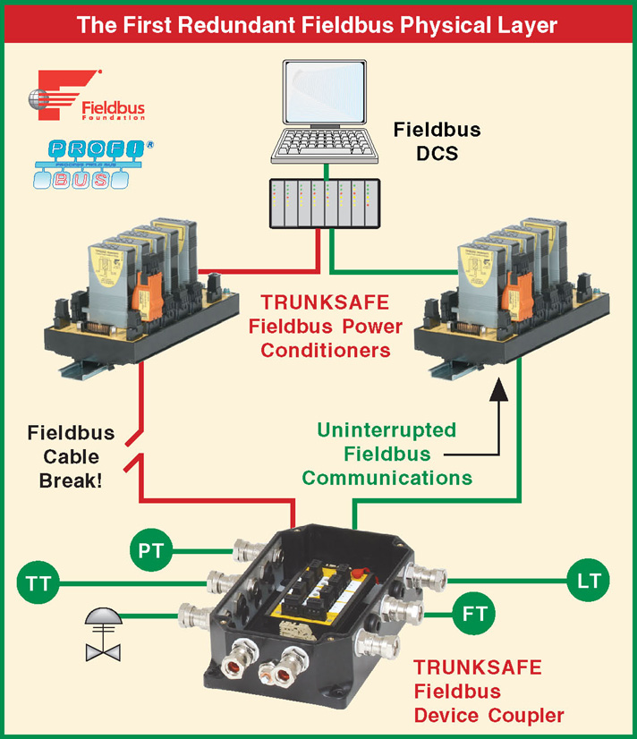

TRUNKSAFE can be used on both critical and non-critical processes, on both FOUNDATION fieldbus and Profibus segments, and it can be used in combination with MooreHawke’s standard fieldbus power conditioner system.

For more information, contact Moore Industries-International, Inc., 16650 Schoenborn St., North Hills, CA 91343, U.S.A; Telephone: (818) 894-7111; FAX: (818) 891-2816; E-mail: info@miinet.com; Web Site: www.miinet.com

# # #

